**Exercise 1:**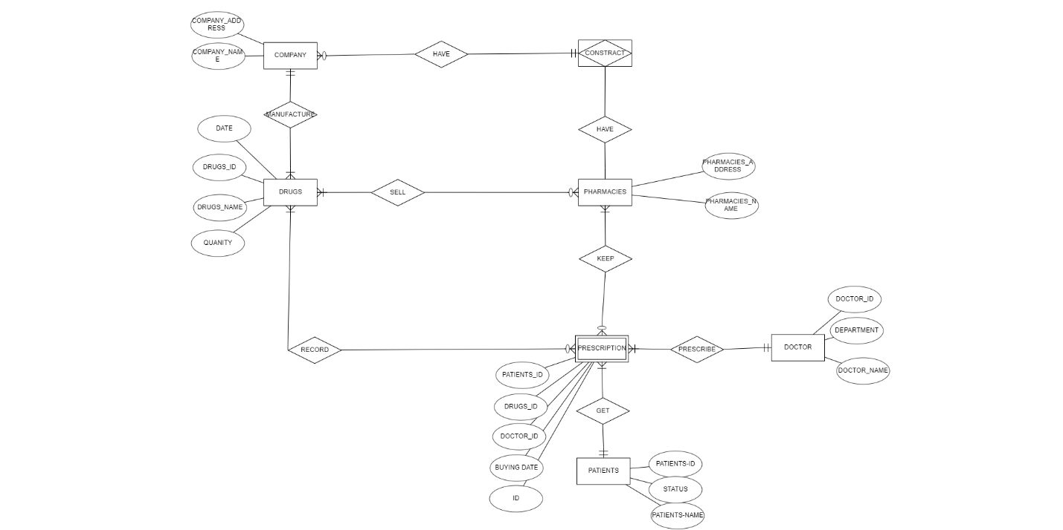

**Exercise 2: **

**Exercise 3:**

Exercise 3:

ID INT

Name VARCHAR(100)

Code CHAR(5)

ModifiedDate DATETIME

**Exercise 4:**

ID INT

Name NVARCHAR(100)

BirthDate DATE

Gender INT

IsDeletedFlag BIT